
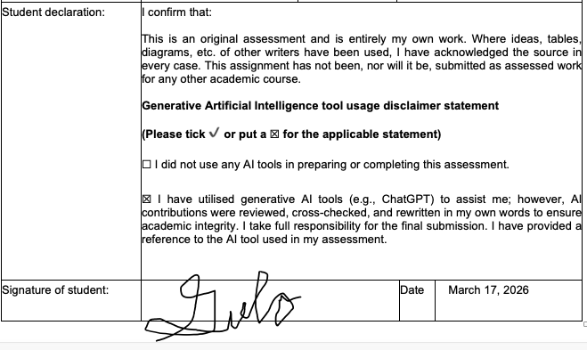
Case Study
Southern Cross is a leading health insurance provider in New Zealand, offering services such as life, health, pet, and travel insurance (Southern Cross Healthcare). The company focuses on delivering accessible and reliable insurance solutions to its members.
Currently, Southern Cross uses Aimee, an AI chatbot that answers customer questions about the health system and insurance terms (McGregor, 2019). While helpful for general inquiries, Aimee’s capabilities are limited and do not provide personalized guidance.
In the future, Aimee could be enhanced to assist with claims, estimate coverage in real time, and offer tailored plan suggestions based on individual profiles and health history. This would transform her into a proactive digital assistant, improving the overall member experience.
To achieve this, Southern Cross will develop and train advanced AI models, integrate comprehensive data governance and security measures (MinterEllison New Zealand, 2025), and adopt Agile methods for continuous improvement..

Transformation of Southern Cross Health AI Chatbot
1.Introduction
In today’s age, chatbots plays a huge part in the success of organizations, not just insurance organizations. Chatbots, also referred to as conversational agents, are interactive intelligent systems that utilize Natural Language Processing (NLP) and machine learning to conduct text or voice-based conversations with humans (Rodríguez Cardona et al., 2021).
In the insurance industry, chatbots are vital for driving digital transformation and helping traditional companies remain competitive against emerging Insurance tech startups (Subhashini et al., 2025). They provide critical 24/7 availability, allowing policyholders to receive immediate clarifications on policy features, premium payments, and claim procedures (Ezhilarasi, 2025).
Southern Cross, New Zealand’s leader in providing health insurance. Southern Cross currently has different cashflow or services such as life insurance, health insurance, pet insurance, and travel insurance(Southern Cross). For Southern Cross, the transformation of the ai chatbot will drive operational efficiency, enhance customer engagement, and provide a strategic competitive advantage in a market increasingly disrupted by Insurance Tech startups (Rodríguez Cardona et al., 2019).
This report will analyse the transformation of AI Chatbot for Southern Cross. Part two will discuss the evolution of AI Chatbot, and the present policies and management regarding the AI Chatbot in Southern Cross. Part three will discuss the current trends and future development of AI Chatbot. Part four will discuss the recommendations and will conclude with the summary in part five.
2. Evolution of Chatbot System at Southern Cross Health
A number of changes have happened in how Southern Cross Healthcare has been manging the policies and the procedures related to their AI chatbot system. Below, we talk about their current state of the art in terms of Managerial policies and procedures.
2.1 Present Management Policies and Procedures
The development and deployment of Southern Cross AI chatbot, Aimee, represents a shift from a simple infrastructure to a strategic organizational capability. As the management team, the goal is to transition the firm from a reactive(detect and repair) model to a proactive (forecast and prevent) framework (O’Connell et al., 2025).
Regarding the Governance on the content and the system. A multidisciplinary team, overseen by the system manager, decides which information is added to the knowledge base. This team must include clinical or subject-matter experts if the bot handles specialized data (e.g., healthcare or finance)(Azadboni et al., 2025). Policies include the following: “Only authorized developers with specific administrative roles may execute functions to add users, modify role hierarchies, or update the bot’s core code” (Cruz et al., 2018), and “All administrative actions committed within the system must be reflected in the event logs, ensuring that no secret changes can be made to the system's logic” (Cruz et al., 2018).
Regarding Security Education, Training, and Awareness (SETA), it is a vital managerial program designed to protect information assets by providing targeted knowledge and skills to the organization (Zheng et al., 2023). For the Aimee development team, SETA functions as a formal management procedure to reduce accidental security breaches caused by a lack of awareness regarding Information Systems Security (ISS) (Nwachukwu et al., 2023). The procedure begins by conducting an initial assessment of employee security awareness through surveys or quizzes to identify current knowledge gaps. Management then identify and classify different audiences (e.g., developers vs. administrative staff) to ensure the training content is suitable for their specific roles. Then a yearly plan will be made to align with SETA goals with the organization’s broader strategy and specific regulations, such as GDPR or HIPAA (Alyami et al., 2024).
Examples of SETA training for employees include Phishing Simulations where users receive "fake" phishing emails; those who click are often redirected to a landing page with immediate, contextual training on how to spot such attacks in the future (Kävrestad et al., 2023), Out-of-Bands Simulations where simulations of safe and digital environments are used by learners to experience and react to simulated attacks, such as ransomware or data breaches, without risking real assets (Kävrestad et al., 2023), Interactive Security Challenges where practical tests are used to measure an employee's ability to apply security policies to their specific job function (McConnell, 2020), Hands-on Software Training where employees use live demonstrations and practice sessions using specific security tools, such as encryption software (Nwachukwu et al., 2023), Role-Specific Training where employees use targeted materials for different audiences, such as physicians (focusing on patient data privacy) versus IT administrators (focusing on server security) (Rampold et al., 2024), Recorded Lectures, Infographics and Posters, Leaflets and Manuals, Screen Savers and Program Reminders, etc. (Kitsios et al., 2022). Below are the policies discussed in more detail.
Regarding the safeguard of sensitive data, management must enforce strict Role-Based Access Control (RBAC) model to provide access control and authentication policy, permissions are granted to roles rather than individual users to reduce administrative overhead and ensure stability (Das et al., 2018). The Least Privilege principle is mandatory: “Users and system components are granted only the minimum permissions necessary for their specific management tasks” (Azadboni et al., 2025), and “Access decisions for the chatbot’s backend must be based on the principle of least privilege, ensuring users only have access to the minimum data required for their specific tasks” (Atlam & Yang, 2025). This also includes Multi-Factor Authentication. “Access to management interfaces, conversation histories, and the core knowledge base requires Multi-Factor Authentication and unique user IDs” (Silva & Canedo, 2025).
Regarding Data Privacy and Security Rules during development, management policies must align with international standards such as GDPR and ISO/IEC 27001 (Silva & Canedo, 2025). Policy dictates that “only absolutely necessary data for the intended purpose is collected and stored”, “All data, both at rest and in transit, must be protected using strong encryption algorithms”, one example of reliable encryption as AES-256 (Ayyadurai & S., 2018), “Personally Identifiable Information (PII) must be automatically redacted or anonymized during the transmission of messages and before data is fed back into ML models for retraining” (Silva & Canedo, 2025), “Only authorized developers with specific administrative roles may execute functions to add users, modify role hierarchies, or update the bot’s core code” (Cruz et al., 2018), and “All administrative actions committed within the system must be reflected in the event logs, ensuring that no "secret" changes can be made to the system's logic” (Cruz et al., 2018).
3. Current Trends and Future Developments
There are a number technology that is up for adoption in term AI Chatbot in the domain of hardware, software, network, and data. Some of such technology is analysed below that well suit the needs of Southern Cross Healthcare.
3.1 Current Trends in AI Chatbot
Currently, the Southern Cross Health’s chatbot, Aimee, functions primarily as a virtual crew member for Southern Cross. Her main job is to make health insurance less confusing by explaining how the NZ health system works and the value of different plans. While she uses machine learning to get better over time, she is not yet the fully integrated co-pilot that can manage your entire policy or handle your money directly (McGregor, 2019).
Similar to Siri and other AI digital assistants, Aimee is powered by artificial intelligence and has a conversational UI interface. But what makes Aimee different is that she has a realistic-looking 3D human face. The idea is that as a customer, you can interact with Aimee via smartphone, tablet, or computer, as if you were talking to a real human customer service representative by doing real time video (Paredes, 2019).
But aside from having a realistically human face, what makes Southern Cross Aimee different from other AI digital channels is her improved ability to respond with empathy and warmth. Aimee represents the AI chatbot technology that is able to recognise conversational cues and behaviours and pick up context and meaning. But to reach Aimee’s full potential, Aimee will need to improve to earn the trust of Southern Cross customers (Paredes, 2019).
3.1 future developments in AI Chatbot
Today, chatbots are driven by many advancements today, it is listed in the following:
- Modern chatbots are moving away from rigid decision-tree logic and toward advanced models like BERT and GPT-4. This allows them to parse complex natural language queries, generate human-like responses, and handle topic changing mid-conversation.
- Use of Natural Language Processing (NLP) and Large Language Models (LLMs). A dominant trend is the hybrid operational model, where chatbots handle basic routine tasks (policy FAQs, status updates) and human agents manage complex, high-value, or emotionally sensitive cases (Pirilä et al., 2022).
- Use of Retrieval-Augmented-Generation to ensure chatbot responses are grounded in an insurer's verified document folders rather than general internet knowledge, which significantly reduces the risk of "hallucinations" or fake information and protects data privacy (Vuohelainen, 2024).
- Use of chatbots for lead generation, cross-selling, and up-selling by analyzing customer data in real-time to offer personalized recommendations during a session (Götzer, 2024).
- Use of chatbots to handle and settle simple, high-frequency claims (like property damage or stolen items) in seconds. One example is the insurance company Lemonade, Inc where they use “AI Jim" system tin settling claims. “AI Jim” can settle claim in as little as three seconds (Tase, 2024).
3. 3 Transition of Southern Cross Chatbot from current to goal state
Currently, the capabilities of Southern Cross’s Aimee is listed in the following:
- Answer common questions such as the value of health insurance and how the health system works. Aimee can also define specific industry terms, such as "pre-existing conditions," in easy-to-understand language. (Paredes, 2019).
- Acts as a virtual "crew member," providing information on insurance value and processes at any time via desktop, tablet, or smartphone (McGregor, 2019).
- Aimee can process and interpret what is said to her during a conversation and respond accordingly, rather than just matching keywords (McGregor, 2019).
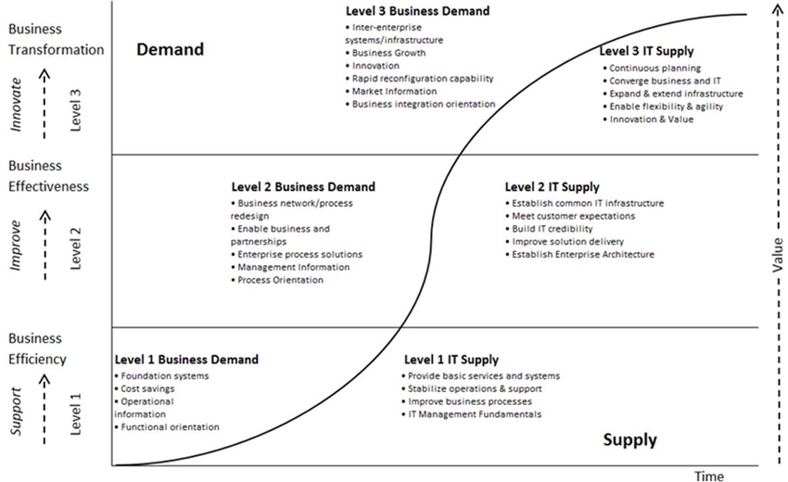
Figure 1 Merlyn's Maturity Model
Using the Merlyn’s Maturity Model, which is shown in the image below (Müller et al., 2015). We can check what level is Aimee currently at. We know that it is not level one since Aimee wasn’t just created to fulfil a request, Aimee was created to solve a business challenge, helping customers in understanding difficult insurance jargon and are too embarrassed to call/ask an insurance advisor/broker (MacManus, 2019). This is why it is at level two. We also know it is not level three since we know that while Aimee is innovative, Aimee hasn't transformed yet the core commercial structure of Southern Cross in a way that creates a new, entirely tech-driven market advantage (McGregor, 2019).
With the vision of Southern Cross to deliver healthier years for more New Zealanders, and inspire people to advance their health and wellbeing and live well for longer (Southern Cross, 2023). We can use TOGAF or Zachman to transform Southern Cross Aimee to the future/goal states mentioned above.
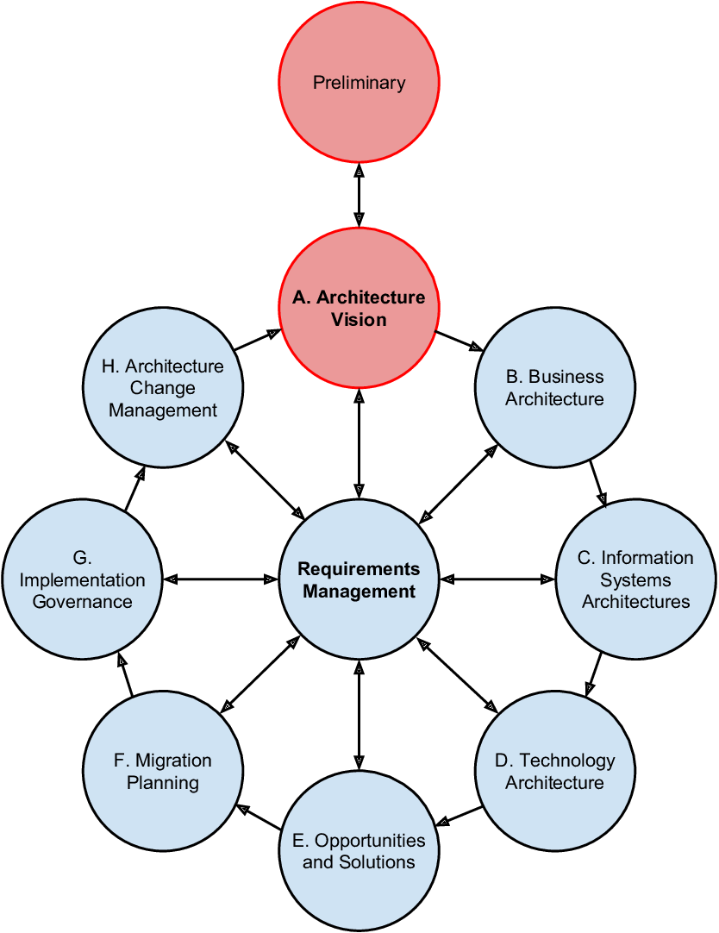
Figure 2 TOGAF Framework (Martakis, 2015)
When we use TOGAF, we need to identify first the architecture vision or the understanding between current state and goal state (Rybalchenko, 2024). We can say that for Aimee, the goal automate some processes, reduce claim submission time, and personalize customer service (Anindita & Huda, 2025).
Second is to identify the business architecture which is to map out the business processes that the chatbot will handle to identify areas for optimization. We can say that for Aimee, the goal is to be able to analyse processes like claim submission, insurance registration, and promotion to see where the chatbot can automate routine tasks (Anindita & Huda, 2025).
Third is the Information Systems Architecture, which is to define the data and application architecture (Tan, 2023). For the data architecture, we focus on data availability and quality, we can use techniques like Retrieval-Augmented Generation to allow the chatbot to access up-to-date, organization-specific data (e.g., policy manuals) instead of relying solely on pre-trained information (Vuohelainen, 2024). For the application architecture, we should ensure the chatbot can call backend APIs to check a customer's account status or billing information in real-time (Crosley et al., 2023).
Fourth is the Technology Architecture, which is to identify the hardware and software needed to support advanced AI features (Maketas & Zisopoulos, 2013). For Aimee, we choose the appropriate Large Language Model (LLM), such as GPT-4o or BERT, and selecting frameworks like LangChain for prompt management (Brancati, 2025). For the infrastructure, deploying technologies like Apache Kafka for real-time query processing and cloud-based systems like AWS and Google Cloud to ensure scalability (Bello, 2025).
Fifth is the Opportunities, Solutions, and Migration. This is where we focus on the practical transition from the current state to the improved goal state (Pisoni et al., 2021). For Aimee, we don't upgrade everything at once. Starting with small-scale pilot projects in non-critical areas to build organizational confidence before expanding to complex tasks like automated underwriting (Tase, 2024). Here we also define KPIs early, such as customer satisfaction (CSAT) or first-contact resolution rates, to measure the improvement of the chatbot over time (Pant, 2025).
Sixth is the Governance and Change Management, where we ensure that the implementation remains compliant and the organization can adapt to the rapid evolution of AI technology (Vuohelainen, 2024). Here we establishing AI Ethics Review Boards and implementing automated checks to ensure real-time adherence to regulations like GDPR, HIPAA, and the EU AI Act (Vuohelainen, 2024). Here we also implement procedures for quarterly audits to detect model drift or algorithmic bias in the chatbot's decision-making (Pareek, 2024). We also ensure that the architecture is flexible enough to allow for the quick replacement of LLMs as new, more efficient models emerge (Wöger, 2024).
4. Recommendations
Future developments of AI Chatbot in the insurance industry signify a move toward a proactive, hyper-personalized, and deeply integrated ecosystem where bots act as Real-Time Data Analyst for both customers and employees (O’Connell et al., 2025).
More future developments of AI Chatbot is discussed in detail in the following:
- Models like Google’s Gemini (formerly Bard) are setting the standard for leveraging real-time internet data for problem-solving, a feature likely to become standard for corporate tools (Wangsa et al., 2024).
- Leveraging IoT and sensor data from smart homes and vehicles to alert policyholders to hazards before a loss occurs, such as detecting water leaks or suggesting roof reinforcements before storm seasons (William, 2025).
- Simulation of complex disaster scenarios more accurately than traditional models, allowing insurers to Price catastrophe risk better and optimize response strategies (Dolzhich, 2024).
- Move away from standard offerings toward individualized, real-time insurance solutions. By 2030, it is predicted that 50% of all insurance products will be dynamically priced and personalized in real-time based on actual behavior data from telematics and wearables (Tase, 2024).
- Act as advisors, rewarding policyholders with lower premiums for safe driving habits or healthy lifestyles tracked through connected devices (Dolzhich, 2024).
- Future chatbots will be trained to detect and appropriately respond to emotional cues and voice tones, providing more empathetic support during critical life events like illness or death (Pareek, 2024).
- Future chatbots will act as maintenance assistants, providing primary insights to troubleshoot faulty equipment in real-time, thereby drastically reducing factory downtime (Kiangala & Wang, 2024).
- Chatbots will serve as expert advisors, identifying knowledge gaps in new employees and directing information flow to train them effectively on assembly lines (Kiangala & Wang, 2024).
Rather than mere replacement, the focus is on upskilling workers to interact efficiently with machines, promoting human well-being and reducing the fear of job displacement often associated with AI (Kiangala & Wang, 2024).
While the capabilities of Southern Cross’s Aimee are lagging behind, we can get it up to date with the current capabilities of chatbots as well as future capabilities.
5. Summary and Conclusion
For Southern Cross, the transformation of Aimee, their AI Chatbot from the simple AI Chatbot to the more sophisticated AI Chatbot with real-time data analytics will transform how data can help customers and employees with decision making. Currently, Southern Cross Aimee is currently using Uneeq’s Intelligent Digital Human Platform, to empower Kiwis to make the best decisions when it comes to their health insurance (McGregor, 2019), but current sophisticated AI Chatbot uses BERT and GPT-4 which allows them to parse complex natural language queries, generate human-like responses, provide real time analytics for both customers and employees. Looking ahead, AI Chatbots in the insurance industry signify a move toward a proactive, hyper-personalized, and deeply integrated ecosystem where AI Chatbots can now provide real time pricing of insurance products, and detect and warn users of impending danger.
As the manager in charge of managing the transformation of Southern Cross Aimee, it is important to focus the things that I have impact on, such as providing management procedures and policies more focused on security such as providing Security Education, Training, and Awareness (SETA) to employees, making sure employees follow company policies to improve overall security.
6. References
Alyami, A., Sammon, D., Neville, K., & Mahony, C. (2024). Critical success factors for Security Education, Training and Awareness (SETA) programme effectiveness: An empirical comparison of practitioner perspectives. Information and Computer Security, 32(1), 53–73. https://doi.org/10.1108/ICS-08-2022-0133
Anindita, T., & Huda, M. Q. (2025). TOGAF ADM Framework Design at Private Insurance Company PT Tugu Pratama. Syarif Hidayatullah State Islamic University. https://www.uinjkt.ac.id
Atlam, H. F., & Yang, Y. (2025). Enhancing Healthcare Security: A Unified RBAC and ABAC Risk-Aware Access Control Approach. Future Internet, 17(6), 262. https://doi.org/10.3390/fi17060262
Ayyadurai, R., & S., V. (2018). Transforming Customer Experience in Banking with Cloud-Based Robo-Advisors and Chatbot Integration. International Journal of Management and Marketing (IJMM), 6(3), 9.
Azadboni, T. T., Solat, F., Hematti, H., & Rahmani, M. (2025). Information security and confidentiality in health chatbots: A scoping review and development of a conceptual model. DIGITAL HEALTH, 11. https://doi.org/10.1177/20552076251406637
Bello, S. (2025). Customer-Facing Financial Chatbots in Insurance. ResearchGate. https://www.researchgate.net/publication/394530963_Customer-Facing_Financial_Chatbots_in_Insurance
Brancati, I. (2025). Generative Artificial Intelligence for Insurance: Developing a chatbot for Multi-Document Summarization of Insurance Products. Politecnico di Torino.
Crosley, N., Indrajit, R. E., & Dazki, E. (2023). TOGAF Framework For an AI-enabled Software House. Sinkron : Jurnal Dan Penelitian Teknik Informatika, 7(2), 1142–1152. https://doi.org/10.33395/sinkron.v8i2.12390
Cruz, J. P., Kaji, Y., & Yanai, N. (2018). RBAC-SC: Role-Based Access Control Using Smart Contract. IEEE Access, 6, 12240–12251. https://doi.org/10.1109/ACCESS.2018.2814839
Das, S., Mitra, B., Atluri, V., Vaidya, J., & Sural, S. (2018). Policy Engineering in RBAC and ABAC. In From Database to Cyber Security (pp. 24–54). Springer International Publishing. https://doi.org/10.1007/978-3-030-04834-1_2
Dolzhich, E. (2024). The Role of AI and Machine Learning in Shaping the Future of Insurance.
Ezhilarasi, A. (2025). AI chatbot interactions and customer satisfaction in the insurance sector: Evidence from Star Health & Allied Insurance Company Limited in Chennai.
Götzer, J. (2024). Engineering and User Experience of Chatbots in the Context of Damage Recording for Insurance Companies. University of Stuttgart.
Kävrestad, J., Nohlberg, M., & Furnell, S. (2023). A Taxonomy of SETA Methods and Linkage to Delivery Preferences. The DATA BASE for Advances in Information Systems, 54(4), 107–133. https://doi.org/10.1145/3631341.3631348
Kiangala, K. S., & Wang, Z. (2024). An experimental hybrid customized AI and generative AI chatbot human machine interface to improve a factory troubleshooting downtime in the context of Industry 5.0. The International Journal of Advanced Manufacturing Technology, 132(5), 2715–2733.
Kitsios, F., Chatzidimitriou, E., & Kamariotou, M. (2022). Developing a Risk Analysis Strategy Framework for Impact Assessment in Information Security Management Systems: A Case Study in IT Consulting Industry. Sustainability, 14(3), 1269. https://doi.org/10.3390/su14031269
MacManus, R. (2019). The digital human who wants to talk to you about your health insurance. The Spinoff. https://thespinoff.co.nz/partner/12-12-2019/the-digital-human-who-wants-to-talk-to-you-about-your-health-insurance
Maketas, D., & Zisopoulos, I. (2013). Integration of TOGAF and SABSA on the Increased Effectiveness and Security of a Software Development Life Cycle, in the Context of a Spinoff Company [Luleå University of Technology]. https://www.diva-portal.org
Martakis, A. (2015). Framework for Enterprise Uncertainty-Driven Decision-Making. https://doi.org/10.13140/RG.2.1.3578.2165
McConnell, J. P., Jr. (2020). UNIX Administrator Information Security Policy Compliance: The Influence of a Focused SETA Workshop and Interactive Security Challenges on Heuristics and Biases [Nova Southeastern University]. https://nsuworks.nova.edu
McGregor, A. (2019, November 21). Human touch meets AI on health insurance frontline. Southern Cross NZ. https://www.southerncross.co.nz/news/2019/health-insurance-ai-digital-human
MinterEllison New Zealand. (2025, November 10). AI risks: What do insurers want to know about your use of AI? MinterEllison NZ Insights. https://www.minterellison.co.nz/insights/ai-risks-what-do-insurers-want-to-know-about-your
Müller, S., Holm, S., & Søndergaard, J. (2015). Benefits of Cloud Computing: Literature Review in a Maturity Model Perspective. Communications of the Association for Information Systems, 37. https://doi.org/10.17705/1CAIS.03742
Nwachukwu, U., Vidgren, J., Niemimaa, M., & Järveläinen, J. (2023). Do SETA Interventions Change Security Behavior? – A Literature Review. 6300–6309. https://hdl.handle.net/10125/103396
O’Connell, M., Bennett, K., & Ward, P. (2025). The Conversational Revolution in Insurance: A Mixed-Methods Study on the Efficacy and Implementation Challenges of Chatbots for Real-Time Data Analysis in Insurance Underwriting, Claims, and Risk Management. ResearchGate. https://www.researchgate.net/publication/396509124_The_Conversational_Revolution_in_Insurance_A_Mixed-Methods_Study_on_the_Efficacy_and_Implementation_Challenges_of_Chatbots_for_Real-Time_Data_Analysis_in_Insurance_Underwriting_Claims_and_Risk_Managem
Pant, P. (2025). Revolutionizing Insurance Data Modernization: Enhancing Property and Casualty Insurance with Cloud Solutions, Data Lakes, and Real-Time Reporting to Propel Advanced Analytics, Ensure Unified Governance and Compliance, and Foster Innovation and Experimentation. Journal of Computational Analysis and Applications, 34(5), 187–200.
Paredes, D. (2019). Digital human joins customer service team at Southern Cross Health Society. CIO. https://www.cio.com/article/201607/digital-human-joins-customer-service-team-at-southern-cross-health-society.html
Pareek, C. S. (2024). Beyond Automation: A Rigorous Testing Framework for Reliable AI Chatbots in Life Insurance. International Journal of Science and Research (IJSR), 13(6), 1485–1493.
Pirilä, T., Salminen, J., Osburg, V.-S., Yoganathan, V., & Jansen, B. J. (2022). Investigating the Role of Technical and Process Quality in Chatbots: A Case Study from the Insurance Industry. 1485–1494. https://hdl.handle.net
Pisoni, G., Molnár, B., & Tarcsi, Á. (2021). Data Science for Finance: Best-Suited Methods and Enterprise Architectures. Applied System Innovation, 4(3), 69. https://doi.org/10.3390/asi4030069
Rampold, F., Heinsohn, J., Schütz, F., Klein, J., Keller, T., Masuch, K., & Warwas, J. (2024). Custom Solutions for Diverse Needs: Laying the Foundation for Tailored SETA Programs in the Healthcare Domain. 3719–3728. https://aisel.aisnet.org/hicss-57/hc/security_and_privacy/2/
Rodríguez Cardona, D., Janssen, A., Guhr, N., Breitner, M. H., & Milde, J. (2021). A matter of trust? Examination of chatbot usage in insurance business.
Rodríguez Cardona, D., Werth, O., Schönborn, S., & Breitner, M. H. (2019). A mixed methods analysis of the adoption and diffusion of chatbot technology in the German insurance sector.
Rybalchenko, A. (2024). Integration von KI als Designelement auf Unternehmensarchitekturebene für Finanzinstitute. In Wirtschaftsinformatik.
Silva, G. R. S., & Canedo, E. D. (2025). Privacy in Chatbot Conversation-Driven Development: A Comprehensive Review and Requirements Proposal. ACM Transactions on Software Engineering and Methodology, 34(7), 1–44. https://doi.org/10.1145/3730578
Southern Cross. (2023). Community Impact Report 2023. Southern Cross. https://www.southerncross.co.nz/-/media/group/community/community-impact-report-2023/community-impact-report-2023-final.pdf
Southern Cross. About Southern Cross. https://www.southerncross.co.nz/about-southern-cross
Subhashini, V., Anusha, T., Swathi, M., & Sridhar, K. (2025). AI powered chatbot in health insurance.
Tan, L. H. (2023). Consumer reaction to the use of artificial intelligence chatbot on distribution of general insurance in Singapore [Singapore Management University]. https://ink.library.smu.edu.sg
Tase, J. (2024). Generative AI in Insurance Industries: Transforming Workflows and Enhancing Customer Experience. International Research Journal of Engineering Science Technology and Innovation, 11(7), 512–519.
Vuohelainen, R. (2024). ARTIFICIAL INTELLIGENCE (AI) AND ROBOTIC PROCESS AUTOMATION (RPA) IN THE INSURANCE BUSINESS. Centria University of Applied Sciences.
